

***Operating Lease Support System Phase-2 Project***

***for***



***Functional Specification***

***FC.AE.1.5***

***Manage Return Authorization Letter (RAL)***

Revision 0.2

**PT. Berlian Sistem Informasi**

KTB Annex Bld. 4th Floor, Jl. Jend. A. Yani. Pulomas,

Tel. +62 21 4786 7575 (Hunting) Fax. +62 21 4714964 www.bsi.co.id

Document Control

|  |  |
| --- | --- |
| **Author** | Amal Hamzah |
| **File Name** |  |
| **Directory Address** | 2 |
| **Number of Page** | 41 |

Revision History

|  |  |  |  |
| --- | --- | --- | --- |
| **Date** | **Revision** | **Description** | **Author** |
| 16/11/2015 | 0.0 | Initialization | Amal Hamzah |
| 28/12/2015 | 0.1 | Update Screen Design, Add Operation Description, Add Data Structure, Add Screen Item List, Update ERD Design | Bina Rahayu S. |
| 22/01/2016 | 0.2 | Update Screen Design, Component Screen Functionality, Operation Description and Data Structure | Amla Hamzah |
|  |  |  |  |

Distribution List

|  |  |  |
| --- | --- | --- |
| Name | Organization | Roles |
| Mr. Yutaro Sanada | Dipo Star Finance, PT | DSF Project Director |
| Mr. Shinji Hosokawa | Dipo Star Finance, PT | DSF Project Director |
| Mr. Shinya Tsukamoto | Dipo Star Finance, PT | DSF IT Advisor |
| Mr. Ahmad Fikri | Dipo Star Finance, PT | DSF IT Advisor |
| Mr. Roby Wijaya | Dipo Star Finance, PT | DSF PMO |
| Mr. Abdul Somad | Dipo Star Finance, PT | DSF Biz. Operation Leader |
| Mr. Mukhlis Ibrahim | Dipo Star Finance, PT | DSF IT Operation Leader |
| Mr. Delta Riangga | Dipo Star Finance, PT | DSF Key User |
| Mr. Mochamad Idris | Dipo Star Finance, PT | DSF Key User |
| Mrs. Herni Hembang | Dipo Star Finance, PT | DSF Key User |
| Mr. Junaidi Didy | Dipo Star Finance, PT | DSF Key User |
| Mr. Dedi Supriyadi | Dipo Star Finance, PT | DSF Key User |
| Mrs. Elke Hilviana | Dipo Star Finance, PT | DSF Key User |
| Mr. Daiki Kamada | Berlian Sistem Informasi, PT | BSI Project Director |
| Mr. Yoshinori Kawahara | Berlian Sistem Informasi, PT | BSI IT Advisor |
| Mr. Satoshi Koibuchi | Berlian Sistem Informasi, PT | BSI IT Advisor |
| Mr. Grand Zah Putra | Berlian Sistem Informasi, PT | BSI Project Manager |
| Mr. Raymond | Berlian Sistem Informasi, PT | BSI Technical Leader |
| Mr. Amal Hamzah | Berlian Sistem Informasi, PT | BSI Business Analyst |

Document Approval

By signing this document I acknowledge I have read the document and give the Project Management Team approval to proceed.

|  |  |  |  |
| --- | --- | --- | --- |
| Role | Name | Signature | Date |
| DSF Project Director | Mr. Yutaro Sanada |  |  |
| DSF Project Director | Mr. Shinji Hosokawa |  |  |
| DSF IT Advisor | Mr. Shinya Tsukamoto |  |  |
| DSF IT Advisor | Mr. Ahmad Fikri |  |  |
| DSF PMO | Mr. Roby Wijaya |  |  |
| DSF DSF Biz. Operation Leader | Mr. Abdul Somad |  |  |
| DSF IT Operation Leader | Mr. Mukhlis Ibrahim |  |  |
| BSI Project Director | Mr. Daiki Kamada |  |  |
| BSI Project Manager | Mr. Grand Zah Putra |  |  |
| BSI Technical Leader | Mr. Raymond |  |  |
| BSI Business Analyst | Mr. Amal Hamzah |  |  |

Table of Contents

Document Control 2

Revision History 2

Distribution List 3

Document Approval 4

1 Introduction 6

1.1 Purpose 6

1.2 Scope 6

1.3 Definition, Acronyms, and Abbreviations 6

1.4 References 7

2 Configuration 7

3 Specification Detail: FC.AE.1.5 Manage RAL 7

3.1 Purpose 7

3.2 Screen of Configuration Access 7

3.3 Screen Functionality 8

3.4 Operation Flow 8

3.5 Screen Design 10

3.6 Component Screen Functionality 13

3.7 Operation Description 18

3.8 Data Structure 34

3.9 Screen Item List 36

3.10 Entity Relationship Diagram 40

* 1. Introduction
  2. Purpose

Functional Specification is a document to describe the detail of functions system which includes screen design, report and logic formula. This document will be used for system development.

* 1. Scope

Functional Specification Document contains screen design, screen functionality, process flow, and data structure of AE.1.5 Manage Return Authorization Letter (RAL)

Here are the scope for AE.1.3 Manage Return Authorization Letter (RAL):

1. **AE.1.5.1 Create RAL**

To create new Return Authorization Letter (RAL) or Surat Kuasa Penarikan Unit for agreement which has already on end contract or overdue billing that need to be terminated.

1. **AE.1.5.2 Edit RAL**

To edit existing Return Authorization Letter (RAL) or Surat Kuasa Penarikan Unit with status DRAFT or REVISED.

1. **AE.1.5.3 Print RAL**

To print Return Authorization Letter (RAL) and convert to PDF/excel for every RAL that already created.

1. **AE.1.5.4 Monitor for RAL Approval**

To monitor approval process for Return Authorization Letter (RAL) and convert to PDF/excel for every RAL that already created.

Output from this functions is:

1. RPT.AE.1.5 List of RAL History Report
2. PF.AE.1.6 RAL (Return Authorization Letter)
   1. Definition, Acronyms, and Abbreviations
3. OPL = Operating Lease
4. TOP = Term Of Payment
5. RAL = Return Authorization Letter (Surat Kuasa Penarikan Unit)
6. BAST = Berita Acara Serah Terima (Handover Report)
7. DSF = Dipo Star Finance
8. HO = Head Office
9. HOB = Head of Branch
10. HOD = Head of Department
11. PIC = Person in Charge
12. Receipt = Kwitansi
13. Notification Letter (Surat Pemberitahuan)
14. Return of Authorization Letter (Surat Peringatan)
    1. References

This functional specification document refers to **“To Be Design” BSI Billing Collection Process**, module:

1. AE.1.5 Manage RAL
   1. Configuration

N/A

* 1. Specification Detail: FC.AE.1.5 Manage RAL
  2. Purpose

Screen of Manage RAL will be used by PIC Collection to manage Return Authorization Letter or Surat Kuasa Penarikan Unit. This screen functions consist List of RAL, Create RAL, Edit RAL, Monitor RAL Status Approval and Print RAL.

This function covered by **“Manage RAL”** screen.

* 1. Screen of Configuration Access

Here are the access right for **“Manage RAL”** screen users:

|  |  |  |  |  |  |
| --- | --- | --- | --- | --- | --- |
| ***User*** | ***Create*** | ***Read*** | ***Update*** | ***Print*** | **Authorization** |
| PIC Collection | v | v | v | v | v |
| Admin | v | v | v | v | v |
| Head of Branch | - | v | - | - | - |
| Head of Department | - | v | - | - | - |
| Regional Manager | - | v | - | - | - |
| Advisor | - | v | - | - | - |
| Director | - | v | - | - | - |
| President Director | - | v | - | - | - |
| Shareholder’s Meeting | - | v | - | - | - |

Legend: v = Have access

Note:

1. Create: related to creation of RAL
2. Read: related to read display RAL
3. Update: related to update data RAL
4. Print: related to print data RAL
5. Authorization: related to accessthe screen
   1. Screen Functionality
6. Display list of RAL
7. Create RAL
8. Edit RAL
9. Print RAL
10. Monitor RAL approval
    1. Operation Flow

Below is operation flow for List of Return of Authorization Letter process refer to **To Be Design Document Billing Collection**, AE.1.5. Manage RAL:

|  |  |
| --- | --- |
| **PIC PC** | **Process** |
|  | Billing Payment Schedule Detail  (TB_BIL_PayScheduleDetail)  Billing Payment Schedule  (TB_BIL_PaySchedule)  Return Authorization Letter  (Tb_BIL_RAL)  Return Authorization Letter Details  (Tb_BIL_RALDtl)  Note:  Source  Output & Input |

Below is operation flow for Create Return of Authorization Letter process refer to **To Be Design Document Billing Collection**, AE.1.5. Manage RAL:

|  |  |
| --- | --- |
| **PIC PC** | **Process** |
|  | Billing Payment Schedule Detail  (TB_BIL_PayScheduleDetail)  Billing Payment Schedule  (TB_BIL_PaySchedule)  Return Authorization Letter  (Tb_BIL_RAL)  Return Authorization Letter Details  (Tb_BIL_RALDtl)    Note:  Source  Output & Input |

Below is operation flow for Edit Return of Authorization Letter process refer to **ToBe Design Document Billing Collection**, AE.1.5. Manage Return of Authorization Letter:

|  |  |
| --- | --- |
| **PIC PC** | **Process** |
|  | Billing Payment Schedule Detail  (TB_BIL_PayScheduleDetail)  Billing Payment Schedule  (TB_BIL_PaySchedule)  Return Authorization Letter  (Tb_BIL_RAL)  Return Authorization Letter Details  (Tb_BIL_RALDtl)    Note:  Source  Output & Input |

Below is operation flow for Return of Authorization LetterApproval process refer to **To Be Design Document Billing Collection**, AE.1.5. Manage Return of Authorization Letter:

|  |  |
| --- | --- |
| **PIC PC** | **Process** |
|  | Billing Payment Schedule Detail  (TB_BIL_PayScheduleDetail)  Billing Payment Schedule  (TB_BIL_PaySchedule)  Return Authorization Letter  (Tb_BIL_RAL)  Return Authorization Letter Details  (Tb_BIL_RALDtl)    Note:  Source  Output & Input |

* 1. Screen Design
* *Initial Screen List of RAL*

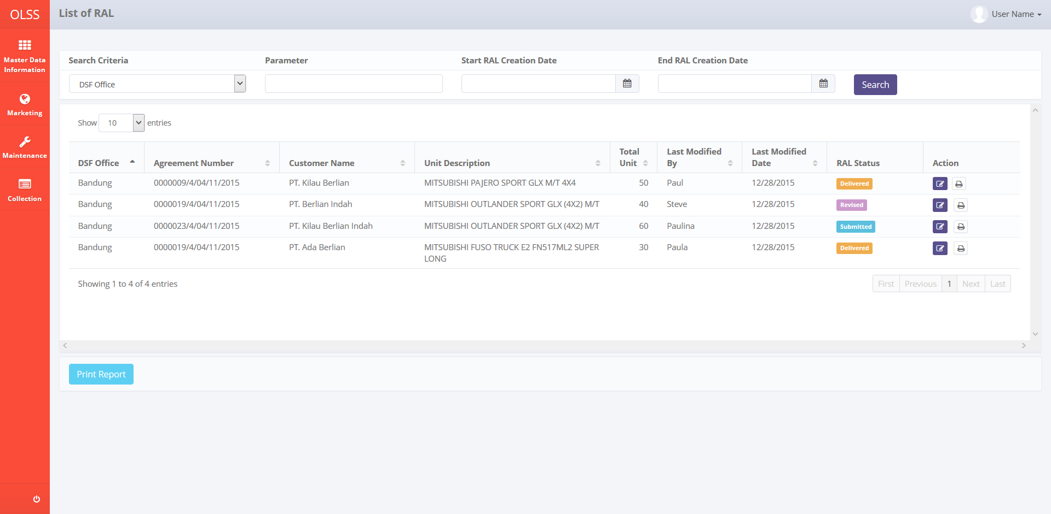

*Screen 1. List of RAL*

* *Screen Design of Create RAL*

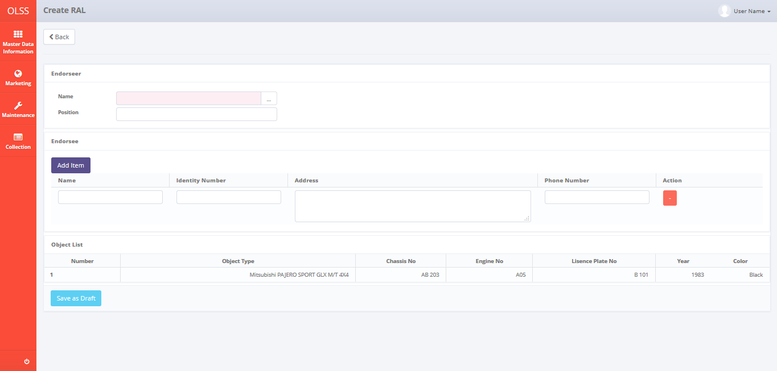

*Screen 2. Create RAL*

* *Screen Design of Create RAL with Search by Employee Role modal dialog*

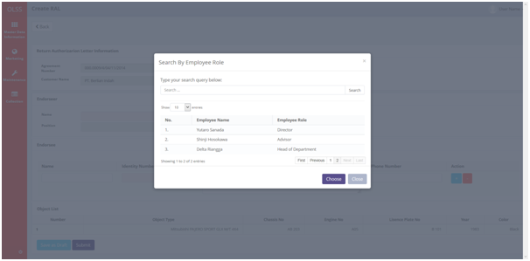

*Screen 3. Search by Employee Role modal dialog*

* *Screen Design of Edit RAL*

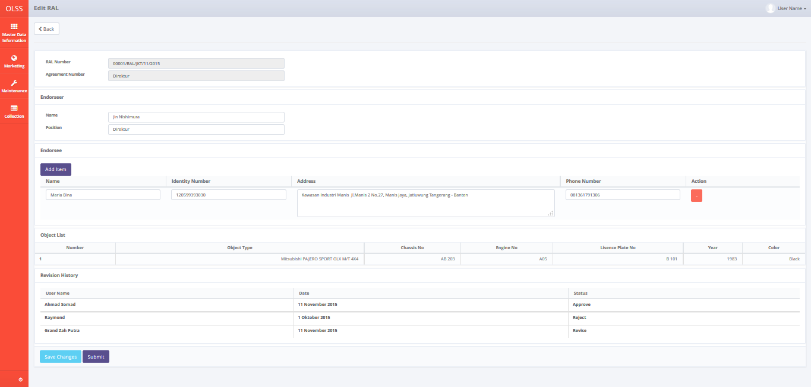

*Screen 4. Edit RAL*

* *Screen Design of Print View RAL*

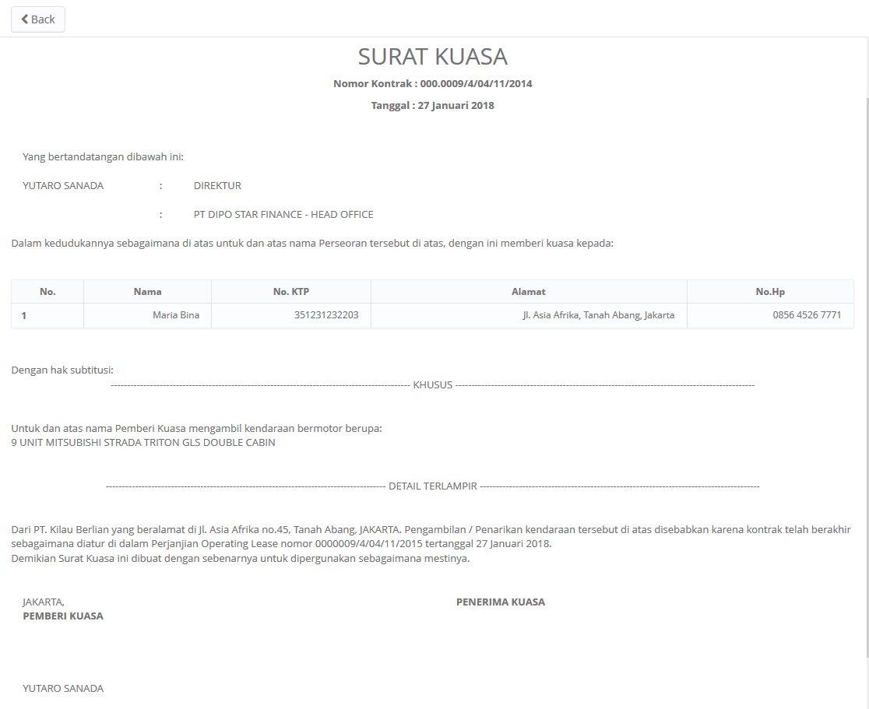

*Screen 5. Print View RAL*

* *Confirmation RAL Pop Up Screen after click button Save as Draft of Return of Authorization Letter*

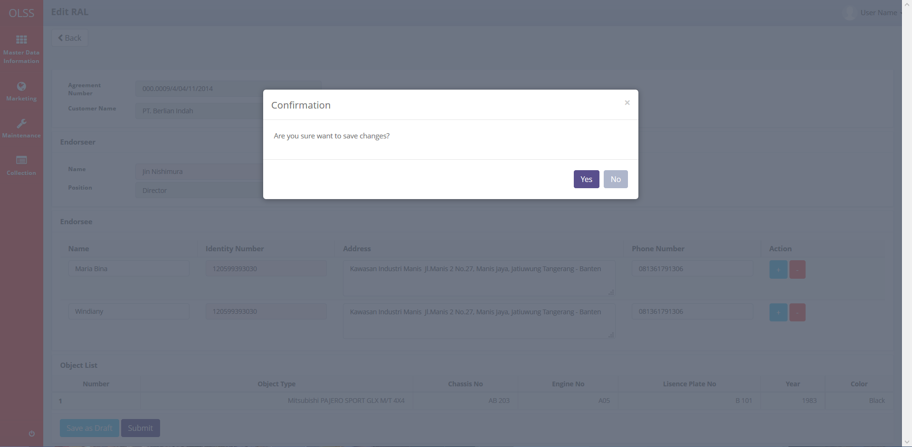

*Screen 6. Save Changes Confirmation Dialog*

* *Notification after Save as Draft, Save Changes, Submit, Check, Revise, Approve, and Reject RAL*

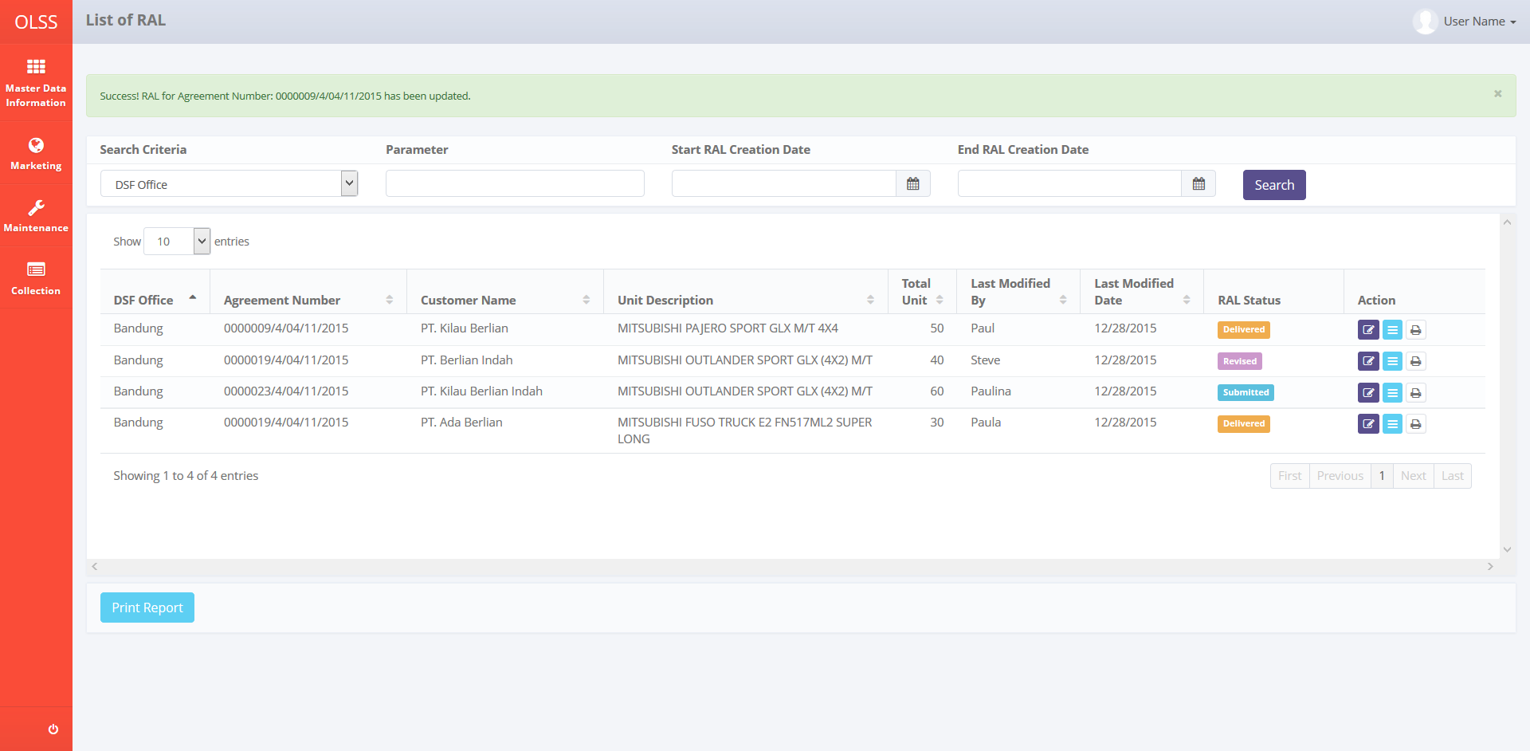

*Screen 7. Save as Draft, Save Changes, Submit, Check, Revise, Approve, or Reject RAL Notification*

* 1. Component Screen Functionality

1. **List of RAL**

Here are the screen functions from each Component in List of RAL screen:

|  |  |  |  |
| --- | --- | --- | --- |
| ***No*** | ***Component*** | ***Name*** | ***Function*** |
| **Header** | | | |
| 1 | Label | List of RAL | Displaying List of RAL Title |
| **Search Criteria** | | | |
| 2 | Drop Down Box | Search Criteria | To select category for searching RAL data |
| 3 | Text Field | Parameter | To input parameter for searching RAL data |
| 4 | Date Picker | Start RAL Creation Date | To input start RAL date based creation of RAL data Report |
| 5 | Date Picker | End RAL Creation Date | To input endRAL date based on creation of RAL data Report |
| 6 | Button | Search | To search RAL data based on selected criteria |
| **List of RAL** | | | |
| 7 | Drop Down Box | Show Entries | To select number of row data that will be displayed in one screen (paging) |
| 8 | Button | Sort | To sort data on table list of RAL ascending and descending |
| 9 | Label | DSF Office | Displaying DSF office |
| 10 | Label | Agreement Number | Displaying Agreement number |
| 11 | Label | Customer Name | Displaying Customer Name |
| 12 | Label | Unit Description | Displaying Unit Description |
| 13 | Label | Total Unit | Displaying Total Unit |
| 14 | Label | Last Modified By | Displaying user name who create RAL |
| 15 | Label | Last Modified Date | Displaying user name who check RAL |
| 16 | Label | RAL Status | Displaying user name who approve RAL |
| 17 | Label | Action | Displaying Action |
| 18 | Button | Edit RAL | To edit RAL |
| 19 | Button | Print RAL | To print RAL |
| 20 | Label | Showing N to M of X entries | Displaying agreement data sequence and the total of Return of Authorization Letter data |
| 21 | Link | First Page | To display first entries page of Return of Authorization Letter data |
| 22 | Link | Previous Page | To display the previous entries page of Return of Authorization Letter data |
| 23 | Link | Page Number | Displaying the page number of the list |
| 24 | Link | Next Page | To display the next entries page of Return of Authorization Letter data |
| 25 | Link | Last Page | To display last entries page of Return of Authorization Letter data |
| **Footer** | | | |
| 26 | Button | Print Report | To print RAL’s Report as shown on the list |

1. **Create RAL**

Here are the screen functions from each Component in Create RAL screen:

|  |  |  |  |
| --- | --- | --- | --- |
| ***No*** | ***Component*** | ***Name*** | ***Function*** |
| **Header** | | | |
| 1 | Label | Create RAL | Displaying Create RAL Title |
| **Create RAL Form** | | | |
| 2 | Button | Back | To go to the previous screen |
| 3 | Label | Return Authorization Letter Information | Displaying Return Authorization Letter Information Title |
| 4 | Label | Agreement Number | Displaying Agreement Number Title |
| 5 | Text Field | Agreement Number | To display Agreement Number of the created RAL |
| 6 | Label | Customer Name | Displaying Customer Name Title |
| 7 | Text Field | Customer Name | To display Customer Name of the created RAL |
| 8 | Label | Endorseer | Displaying Endorseer Title |
| 9 | Label | Name | Displaying Name Title |
| 10 | Search Box | Name | To select Name of the Endorseer for the created RAL |
| 11 | Label | Position | Displaying Position Title |
| 12 | Text Field | Position | To display Position of the Endorseer for the created RAL |
| 13 | Label | Endorsee | Displaying Endorsee Title |
| 14 | Button | Add Item | To add new information of the Endorsee for the created RAL |
| 15 | Label | Name | Displaying Name Title |
| 16 | Text Field | Name | To input Name of the Endorsee for the created RAL |
| 17 | Label | Identify Number | Displaying Identify Number Title |
| 18 | Text Field | Identify Number | To input Identify Number of the Endorsee for the created RAL |
| 19 | Label | Address | Displaying Address Title |
| 20 | Text Field | Address | To input Address of the Endorsee for the created RAL |
| 21 | Label | Phone Number | Displaying Phone Number Title |
| 22 | Text Field | Phone Number | To input Phone Number of the Endorsee for the created RAL |
| 23 | Label | Action | Displaying Action Title |
| 24 | Button | - | To delete information of the Endorsee for the created RAL |
| 25 | Label | Object List | Displaying Object List Title |
| 26 | Label | Number | Displaying Number Title |
| 27 | Label | Object Type | Displaying Object Type Title |
| 28 | Label | Chassis No | Displaying Chassis No Title |
| 29 | Label | Engine No | Displaying Engine No Title |
| 30 | Label | Lisence Plate No | Displaying Lisence Plate No Title |
| 31 | Label | Year | Displaying Year Title |
| 32 | Label | Color | Displaying Color Title |
| **Footer** | | | |
| 33 | Button | Save as Draft | To save RAL which has been created as draft |
| 34 | Button | Submit | To submit RAL which has been created |
| **Search By Employee Role** | | | |
| 35 | Label | Search By Employee Role | Displaying Search By Employee Role |
| 36 | Label | Type your search query below: | Displaying note for user |
| 37 | Text Box | Search… | Text field to input search key of existing Terms and Conditions |
| 38 | Button | Search | To execute search process |
| 39 | Label | No | Displaying the sequence number of search data result |
| 40 | Label | Employee Name | Displaying list of Employee Name |
| 41 | Label | Employee Role | Displaying list of Employee Role |
| 42 | Label | Showing N to M of X entries | Displaying Employee data sequence and the total of Employeedata |
| 43 | Link | First Page | To display first entries page of Employeedata |
| 44 | Link | Previous Page | To display the previous entries page of Employeedata |
| 45 | Link | Page Number | Displaying the Page Number of the List |
| 46 | Link | Next Page | To display the next entries page of Employeedata |
| 47 | Link | Last Page | To display last entries page of Employeedata |
| 48 | Button | Choose | To select employee name |
| 49 | Button | Close | To close pop up window without saving |

1. **Edit RAL**

Here are the screen functions from each Component in Edit RAL screen:

|  |  |  |  |  |
| --- | --- | --- | --- | --- |
| ***No*** | ***Component*** | ***Name*** | ***Function*** | |
| **Header** | | | | |
| 1 | Label | Edit RAL | Displaying Edit RAL Title | |
| **Edit RAL Form** | | | | |
| 2 | Button | Back | To go to the previous screen | |
| 3 | Label | Created by | Displaying RAL creator | |
| 4 | Label | PIC Admin HOD/Branch | To display RAL creator | |
| 5 | Label | Created Date | Displaying RAL creation date | |
| 6 | Label | Created Date Value | To display RAL creation date | |
| 7 | Label | Last Modified By | Displaying last modified | |
| 8 | Label | PIC Admin HOD/Branch | To display name who modify the RAL data | |
| 9 | Label | Last Modified Date | Displaying last modified date | |
| 10 | Label | Last Modified Date Value | To display last modified date | |
| 11 | Label | Return Authorization Letter Information | Displaying Return Authorization Letter Information title | |
| 12 | Label | Agreement Number | Displaying Agreement Number Title | |
| 13 | Text Field | Agreement Number | To display Agreement Number of the created RAL | |
| 14 | Label | Customer Name | Displaying Customer Name Title | |
| 15 | Text Field | Customer Name | To displayCustomer Name of the created RAL | |
| 16 | Label | Endorseer | Displaying Endorseer Title | |
| 17 | Label | Name | Displaying Name Title | |
| 18 | Search Box | Name | To select Name of the Endorseer for the created RAL | |
| 19 | Label | Position | Displaying PositionTitle | |
| 20 | Text Field | Position | To display Position of the Endorseer for the created RAL | |
| 21 | Label | Endorsee | Displaying Endorsee Title | |
| 22 | Button | Add Item | To add new information of the Endorsee for the created RAL | |
| 23 | Label | Name | Displaying Name Title | |
| 24 | Text Field | Name | To input Name of the Endorsee for the created RAL | |
| 25 | Label | Identify Number | Displaying Identify Number Title | |
| 26 | Text Field | Identify Number | To input Identify Number of the Endorsee for the created RAL | |
| 27 | Label | Address | Displaying Address Title | |
| 28 | Text Field | Address | To input Address of the Endorsee for the created RAL | |
| 29 | Label | Phone Number | Displaying Phone Number Title | |
| 30 | Text Field | Phone Number | To input Phone Number of the Endorsee for the created RAL | |
| 31 | Label | Action | Displaying Action Title | |
| 32 | Button | - | To delete information of the Endorsee for the created RAL | |
| 33 | Label | Object List | Displaying Object List Title | |
| 34 | Label | Number | Displaying Number Title | |
| 35 | Label | Object Type | Displaying Object Type Title | |
| 36 | Label | Chassis No | Displaying Chassis No Title | |
| 37 | Label | Engine No | Displaying Engine No Title | |
| 38 | Label | Lisence Plate No | Displaying Lisence Plate No Title | |
| 39 | Label | Year | Displaying Year Title | |
| 40 | Label | Color | Displaying Color Title | |
| 41 | Label | Revision History | Displaying Revision History field name as a sign that below is a Revision History Table | |
| 42 | Label | User Name | Displaying User Name column name of Revision History Table | |
| 43 | Label | Date | Displaying Date column name of Revision History Table | |
| 44 | Label | Status | Displaying Status column name of Revision History Table | |
| **Footer** | | | | |
| 45 | Button | Save Changes | To save RAL which has been edited | |
| 46 | Button | Submit | To submit RAL which has been edited | |
| **Search By Employee Role** | | | | |
| 35 | Label | Search By Employee Role | Displaying Search By Employee Role | |
| 36 | Label | Type your search query below: | Displaying note for user | |
| 37 | Text Field | Search… | Text field to input search key of existing Terms and Conditions | |
| 38 | Button | Search | To execute search process | |
| 39 | Label | No | Displaying the sequence number of search data result | |
| 40 | Label | Employee Name | Displaying list of Employee Name | |
| 41 | Label | Employee Role | Displaying list of Employee Role | |
| 42 | Label | Showing N to M of X entries | Displaying Employee data sequence and the total of Employee data | |
| 43 | Link | First Page | To display first entries page of Employee data | |
| 44 | Link | Previous Page | To display the previous entries page of Employee data | |
| 45 | Link | Page Number | Displaying the Page Number of the List | |
| 46 | Link | Next Page | To display the next entries page of Employee data | |
| 47 | Link | Last Page | To display last entries page of Employee data | |
| 48 | Button | Choose | | To select employee name |
| 49 | Button | Close | | To close pop up window without saving |

* 1. Operation Description

|  |  |  |
| --- | --- | --- |
| **No.** | **Operation Name** | **Description** |
| 1 | Initial view of List of RAL | The screen of list of Return of Authorization Letter:   * 1. Component Status;  |  |  |  |  | | --- | --- | --- | --- | | Component | Name/Caption | Status | Remark | | Label | List of Return of Authorization Letter | Not Active |  | | Drop down box | Search criteria category | Active | As initial by default column name that will be display on drop down is DSF Office | | Text field | Search criteria value | Active |  | | Datepicker | Start RAL Creation Date | Active |  | | Datepicker | End RAL Creation Date | Active |  | | Button | Search | Active |  | | Drop down box | Show | Active | Default value is 10 entries | | Label | DSF Office | Not Active |  | | Label | Agreement Number | Not Active |  | | Label | Customer Name | Not Active |  | | Label | Unit Description | Not Active |  | | Label | Total Unit | Not Active |  | | Label | Last Modified By | Not Active |  | | Label | Last Modified Date | Not Active |  | | Label | RAL Status | Not Active |  | | Label | Action | Not Active |  | | Button | Edit Return of Authorization Letter | Active |  | | Button | View Return of Authorization Letter | Active |  | | Button | Print Return of Authorization Letter | Active |  | | Button | First Page | Active | Active depending on the current entry | | Button | Previous Page | Active | Active depending on the current entry | | Link | Page Number | Active | Active depending on the current entry | | Button | Next Page | Active | Active depending on the current entry | | Button | Last Page | Active | Active depending on the current entry | |
| 2 | Searching the List of Return of Authorization Letter | Input:   1. Select searching criteria category (search criteria), searching criteria value (parameter), Start Return of Authorization Letter Date and End Return of Authorization Letter Date in search field.     Constraint:   1. Search criteria only consists of DSF Office, Agreeement Number, Customer Name, Unit Description, TotalUnit, Last Modified By, Last Modified Date and RAL Status. 2. End RAL Creation Datecan not be less than Start RAL Creation Date (the End RAL Creation Date will be locked for the date before Start RAL Creation Date). 3. Start RAL Creation Date can not be more than End RAL Creation Date (the Start RAL Creation Date will be locked for the date after End RAL Creation Date). 4. Click on the Search Button     Process:   1. The screen will view the list of RAL according to search criteria, sorted by the latest RAL creation date. 2. Based on **Screen 1. List of Return of Authorization Letter**, information related to Return of Authorization Letter that will be display automatically are:  |  |  |  | | --- | --- | --- | | **List of RAL** | **Source** | **Remarks** | | DSF Office | Tb_OPL_Branch.BranchShortName | Where TB_BIL_RAL.IdTb_BIL_PaySchedule = TB_BIL_PaySchedule.IdTb_BIL_PaySchedule  AND  TB_BIL_PaySchedule.IdTb_OPL_Branch = Tb_OPL_Branch.IdTb_OPL_Branch | | Agreement Number | OPLAgreement.AgreementNumber | Where TB_BIL_RAL.IdTb_BIL_PaySchedule = TB_BIL_PaySchedule.IdTb_BIL_PaySchedule  AND  TB_BIL_PaySchedule.IdOPLAgreement = OPLAgreement.IdOPLAgreement | | Customer Name | Customer.CustomerName | Where  TB_BIL_RAL.IdTb_BIL_PaySchedule = TB_BIL_PaySchedule.IdTb_BIL_PaySchedule  AND  TB_BIL_PaySchedule.IdOPLAgreement = OPLAgreement.IdOPLAgreement  AND  OPLAgreement.CustomerCode = Customer.CustomerCode | | Unit Description | Product.BrandName + Product.ModelName | Where TB_BIL_RAL.IdTb_BIL_PaySchedule = TB_BIL_PaySchedule.IdTb_BIL_PaySchedule  AND  TB_BIL_PaySchedule.IdOPLAgreement = Tb_OPL_Unit.IdOPLAgreement  AND  Tb_OPL_Unit.ProductCode = Product.ProductCode | | Total Unit | OPLAgreement.TotalUnitQuantity | Where  TB_BIL_RAL.IdTb_BIL_PaySchedule = TB_BIL_PaySchedule.IdTb_BIL_PaySchedule  AND  TB_BIL_PaySchedule.IdOPLAgreement = OPLAgreement.IdOPLAgreement | | Last Modified By | TB_BIL_RAL_History.CreatedBy (DESC) | Where TB_RAL_BIL_History.IdTb_BIL_RAL = Tb_BIL_RAL.IdTb_BIL_RAL | | Last Modified Date | TB_BIL_RAL_History.CreatedDate (DESC) | Where TB_RAL_BIL_History.IdTb_BIL_RAL = Tb_BIL_RAL.IdTb_BIL_RAL | | RAL Status | TB_OPL_Status.StatusCode | Where  TB_BIL_RAL.RALStatus |  1. Total number data row on the list will be displayed based on selected show number entries. 2. Select number of show list entries: 10, 25, 50, and 100 and click the page for viewing more data, default value is 10. 3. Default view will display data list of Return of Authorization Letter which already created. 4. After click the Search button, the system will get data from Tb_BIL_RAL and Tb_BIL_RALDtl table to be displayed in the list. 5. For RAL data which its status is submitted, the Edit icon button for the related submitted RAL should be disabled.   Output:  N/A |
| 3 | Initial view of Create RAL | The screen of list of Return of Authorization Letter:   1. Component Status;  |  |  |  |  | | --- | --- | --- | --- | | Component | Name/Caption | Status | Remark | | Label | Create RAL | Not Active |  | | Label | Return of Authorization Letter Information | Not Active |  | | Text field | Agreement Number | Not Active |  | | Text field | Customer Name | Not Active |  | | Label | Endorseer | Not Active |  | | Search box | Name | Active |  | | Text field | Position | Not Active | Automatically filled | | Label | Endorsee | Not Active |  | | Label | Name | Not Active |  | | Text field | Name | Active |  | | Label | Identify Number | Not Active |  | | Text field | Identify Number | Active |  | | Label | Address | Not Active |  | | Text field | Address | Active |  | | Label | Phone Number | Not Active |  | | Text field | Phone Number | Active |  | | Label | Action | Not Active |  | | Button | + | Active |  | | Button | - | Active |  | | Label | Object List | Not Active |  | | Label | Number | Not Active |  | | Label | Object Type | Not Active |  | | Label | Chassis No | Not Active |  | | Label | Engine No | Not Active |  | | Label | Lisence Plate No | Not Active |  | | Label | Year | Not Active |  | | Label | Color | Not Active |  | | Button | Save as Draft | Active |  | | Button | Submit | Active |  | |
| 4 | Create Return Authorization Letter | Input:   1. Access menu OLSS 2. Hover to menu Billing Collection 3. Click on Monitor Schedule sub menu 4. Click on End Contract Tab 5. Click on CreateReturn of Authorization Letter icon button     Alternative:   1. Access menu OLSS 2. Hover to menu Billing Collection 3. Click on Monitor Overdue sub menu 4. Click on Create Return of Authorization Letter icon button     Process:   1. System will display Create RAL screen when user click Create Return of Authorization Letter icon button for the related Agreement Number and Customer Name. 2. System will automatically display Agreement Number and Customer Name at Return Authorization Letter Information, Endorseer dialog and Object List data:  |  |  |  | | --- | --- | --- | | **Create RAL Form** | **Source** | **Remarks** | | Agreement Number | OPLAgreement.AgreementNumber | Where TB_BIL_RAL.IdTb_BIL_PaySchedule = TB_BIL_PaySchedule.IdTb_BIL_PaySchedule  AND  TB_BIL_PaySchedule.IdOPLAgreement = OPLAgreement.IdOPLAgreement | | Customer Name | Customer.CustomerName | TB_BIL_RAL.IdTb_BIL_PaySchedule = TB_BIL_PaySchedule.IdTb_BIL_PaySchedule  AND  TB_BIL_PaySchedule.IdOPLAgreement = OPLAgreement.IdOPLAgreement  AND  OPLAgreement.CustomerCode = Customer.CustomerCode | | Endorseer | | | | Name | Tb_OPL_Employee.EmployeeName | Where TB_BIL_RAL.IdTb_OPL_Employee = Tb_OPL_Employee.IdTb_OPL_Employee | | Position | Tb_OPL_Role.RoleName | Where TB_BIL_RAL.IdTb_OPL_Employee = Tb_OPL_Employee.IdTb_OPL_Employee  AND  Tb_OPL_Employee.IdTb_OPL_Role = Tb_OPL_Role.IdTb_OPL_Role | | Object List | | | | Object Type | Product.BrandName + Product.ModelName | Where TB_BIL_RAL.IdTb_BIL_PaySchedule = TB_BIL_PaySchedule.IdTb_BIL_PaySchedule  AND  TB_BIL_PaySchedule.IdOPLAgreement = Tb_OPL_Unit.IdOPLAgreement  AND  Tb_OPL_Unit.ProductCode = Product.ProductCode | | Chassis No | Tb_OPL_Unit.ChassisNo | Where TB_BIL_RAL.IdTb_BIL_PaySchedule = TB_BIL_PaySchedule.IdTb_BIL_PaySchedule  AND  TB_BIL_PaySchedule.IdOPLAgreement = Tb_OPL_Unit.IdOPLAgreement | | Engine No | Tb_OPL_Unit.EngineNo | Where TB_BIL_RAL.IdTb_BIL_PaySchedule = TB_BIL_PaySchedule.IdTb_BIL_PaySchedule  AND  TB_BIL_PaySchedule.IdOPLAgreement = Tb_OPL_Unit.IdOPLAgreement | | Lisence Plate No | Tb_OPL_Unit.LisencePlat | Where TB_BIL_RAL.IdTb_BIL_PaySchedule = TB_BIL_PaySchedule.IdTb_BIL_PaySchedule  AND  TB_BIL_PaySchedule.IdOPLAgreement = Tb_OPL_Unit.IdOPLAgreement | | Year | Product.ProductYear | Where TB_BIL_RAL.IdTb_BIL_PaySchedule = TB_BIL_PaySchedule.IdTb_BIL_PaySchedule  AND  TB_BIL_PaySchedule.IdOPLAgreement = Tb_OPL_Unit.IdOPLAgreement  AND  Tb_OPL_Unit.ProductCode = Product.ProductCode | | Color | Tb_OPL_Unit.Color | Where TB_BIL_RAL.IdTb_BIL_PaySchedule = TB_BIL_PaySchedule.IdTb_BIL_PaySchedule  AND  TB_BIL_PaySchedule.IdOPLAgreement = Tb_OPL_Unit.IdOPLAgreement  AND  Tb_OPL_Unit.ProductCode = Product.ProductCode | | Backend value | | | | DocumentType | 6 | Where 1 = Invoice:  2 = Receipt:  3 = Maintenance Invoice:  4 = Maintenance Receipt:  5 = Warning Letter  6 = RAL  7 = Notification Letter:  8 = Termination Memo:  9 = TandaTerimaDokumen | | RALType | 0 or 1 | 0 if RAL is created from End Contract tab, Monitor Schedule Screen  1 if RAL is created from Overdue Screen |   Constraints:   1. Agreement Data will display in accordance with the selected list data 2. All data refer to Agreement Number above 3. All data are view only, not editable 4. Value for DocumentType will use Enumeration 5. When user click Endorseer’s Name search box, system will display Search by Employee Role modal dialog.   Constraints:   1. Employee Role sort by Tb_OPL_Role.RoleOrderdesc. 2. User should input manually:  |  |  | | --- | --- | | **RAL Form** | **Constraint Input** | | Endorsee | | | Name | Varchar | | Identity Number | Integer | | Address | Varchar | | Phone Number | Integer |  1. When user click Add Item button, system will add new row at Endorsee table.      1. When user click - button, system will delete the selected row at Endorsee table.      1. When user already fill RAL form and want to edit later, then click on button Save as Draft to save data as draft.      1. When button Save as Draft clicked, then confirmation dialog at screen 6 ‘Are you sure you want to save as draft?’ message will be displayed. 2. User can click on Yes button to confirm the changes or click on No button to go back to CreateRAL screen.   Constraint:   1. If clicked with any of the field still hasn’t meet the validation criteria, every notification message for validation below the field will be displayedafter user click Yes button. 2. When User want to proceed to Return of Authorization Letter approval progress, user can click on Submit button.      1. When user click submit button, confirmation dialog at screen6 ‘Are you sure you want to submit?’ message will be displayed.   Constraint:   1. If clicked with any of the field still hasn’t meet the validation criteria, every notification message for validation below the field will be displayed after user click Yes button. 2. When Submit button has been clicked, RAL data cannot be edited anymore. The Edit icon button for the related submitted RAL should be disabled. 3. When Save as Draft button is clicked, System will add a new log of Return of Authorization Letter action to TB_BIL_RAL_History. Data which should be inserted are:  |  |  | | --- | --- | | **Field Name** | **Value** | | ProcessId | New GUID | | OriginalId | TB_BIL_RAL | | CreatedDate | Sys.CurrentDate | | CreatedBy | User.UserName | | Action | TB_OPL_Status.StatusCode = DRAFT |  1. When Submit button is clicked, System will add a new log of Return of Authorization Letter action to TB_BIL_RAL_History. Data which should be inserted are:  |  |  | | --- | --- | | **Field Name** | **Value** | | ProcessId | New GUID | | OriginalId | TB_BIL_RAL | | CreatedDate | Sys.CurrentDate | | CreatedBy | User.UserName | | Action | TB_OPL_Status.StatusCode = SUBMITTED |   Output:   1. A new row at list of Return of Authorization Letter screen will be displayed with its status is **draft** or **submitted**. 2. Display success message on top of List of Return of Authorization Letterwhen Return of Authorization Letter data has been submitted or save changes successfully:   “Success! Your data of RAL in Agreement Number: 002341/4/01/11/2015 has been saved as draft/submitted”  Alternative:  N/A |
| 5 | Edit RAL | Input:   1. Access menu OLSS 2. Hover to menu Billing Collection 3. Click on Monitor Overdue sub menu 4. Click on Manage RAL button button      1. Click on Edit icon button at RAL data which its status is **draft**     Constraint:   1. RAL data which its status is not draft, the Edit icon button is disabled.   Process:   1. System will display data at Edit RAL screen as below:  |  |  |  | | --- | --- | --- | | **RAL Form** | **Source** | **Remarks** | | Audit Trail | |  | | Created by | Tb_BIL_RAL_History.CreatedBy | (oldest creation by) | | Created Date | Tb_BIL_RAL_History.CreatedDate | (oldest creation date) | | Last Modified By | Tb_BIL_RAL_History.CreatedBy | (latest creation by) | | Last Modified Date | Tb_BIL_RAL_History.CreatedDate | (latest creation date) | | RAL Information | |  | | Agreement Number | OPLAgreement.AgreementNumber | Where TB_BIL_RAL.IdTb_BIL_PaySchedule = TB_BIL_PaySchedule.IdTb_BIL_PaySchedule  AND  TB_BIL_PaySchedule.IdOPLAgreement = OPLAgreement.IdOPLAgreement | | Customer Name | Customer.CustomerName | TB_BIL_RAL.IdTb_BIL_PaySchedule = TB_BIL_PaySchedule.IdTb_BIL_PaySchedule  AND  TB_BIL_PaySchedule.IdOPLAgreement = OPLAgreement.IdOPLAgreement  AND  OPLAgreement.CustomerCode = Customer.CustomerCode | | Endorseer | | | | Name | Tb_OPL_Employee.EmployeeName | Where TB_BIL_RAL.IdTb_OPL_Employee = Tb_OPL_Employee.IdTb_OPL_Employee | | Position | Tb_OPL_Role.RoleName | Where TB_BIL_RAL.IdTb_OPL_Employee = Tb_OPL_Employee.IdTb_OPL_Employee  AND  Tb_OPL_Employee.IdTb_OPL_Role = Tb_OPL_Role.IdTb_OPL_Role | | Endorsee | |  | | Name | Tb_BIL_RALDtl.EndorseeName | Where Tb_BIL_RALDtl.IdTb_BIL_RALDtl = Tb_BIL_RAL.IdTb_BIL_RALDtl | | Identity Number | Tb_BIL_RALDtl.EndorseeIDNo | Where Tb_BIL_RALDtl.IdTb_BIL_RALDtl = Tb_BIL_RAL.IdTb_BIL_RALDtl | | Address | Tb_BIL_RALDtl.EndorseeAddress | Where Tb_BIL_RALDtl.IdTb_BIL_RALDtl = Tb_BIL_RAL.IdTb_BIL_RALDtl | | Phone Number | Tb_BIL_RALDtl.EndorseeHPNo | Where Tb_BIL_RALDtl.IdTb_BIL_RALDtl = Tb_BIL_RAL.IdTb_BIL_RALDtl | | Object List | |  | | Number | Automatic generate |  | | Object Type | Product.BrandName + Product.ModelName | Where TB_BIL_RAL.IdTb_BIL_PaySchedule = TB_BIL_PaySchedule.IdTb_BIL_PaySchedule  AND  TB_BIL_PaySchedule.IdOPLAgreement = Tb_OPL_Unit.IdOPLAgreement  AND  Tb_OPL_Unit.ProductCode = Product.ProductCode | | Chassis No | Tb_OPL_Unit.ChassisNo | Where TB_BIL_RAL.IdTb_BIL_PaySchedule = TB_BIL_PaySchedule.IdTb_BIL_PaySchedule  AND  TB_BIL_PaySchedule.IdOPLAgreement = Tb_OPL_Unit.IdOPLAgreement | | Engine No | Tb_OPL_Unit.EngineNo | Where TB_BIL_RAL.IdTb_BIL_PaySchedule = TB_BIL_PaySchedule.IdTb_BIL_PaySchedule  AND  TB_BIL_PaySchedule.IdOPLAgreement = Tb_OPL_Unit.IdOPLAgreement | | Lisence Plate No | Tb_OPL_Unit.LisencePlat | Where TB_BIL_RAL.IdTb_BIL_PaySchedule = TB_BIL_PaySchedule.IdTb_BIL_PaySchedule  AND  TB_BIL_PaySchedule.IdOPLAgreement = Tb_OPL_Unit.IdOPLAgreement | | Year | Product.ProductYear | Where TB_BIL_RAL.IdTb_BIL_PaySchedule = TB_BIL_PaySchedule.IdTb_BIL_PaySchedule  AND  TB_BIL_PaySchedule.IdOPLAgreement = Tb_OPL_Unit.IdOPLAgreement  AND  Tb_OPL_Unit.ProductCode = Product.ProductCode | | Color | Tb_OPL_Unit.Color | Where TB_BIL_RAL.IdTb_BIL_PaySchedule = TB_BIL_PaySchedule.IdTb_BIL_PaySchedule  AND  TB_BIL_PaySchedule.IdOPLAgreement = Tb_OPL_Unit.IdOPLAgreement  AND  Tb_OPL_Unit.ProductCode = Product.ProductCode | | Revision History | | | | User Name | Tb_BIL_RAL_History.CreatedBy |  | | Date | Tb_BIL_RAL_History.CreatedDate |  | | Status | Tb_OPL_Status.StatusName | Where Tb_BIL_RAL_History.Action = Tb_OPL_Status.IdTb_OPL_Status |  1. When Save Changes button is clicked, confirmation dialog at screen 6 ‘Are you sure you want to save changes?’ message will be displayed. 2. When Submit button is clicked, confirmation dialog at screen 6 ‘Are you sure you want to submit?’ message will be displayed.   Constraint:   1. If clicked with any of the field still hasn’t meet the validation criteria, every notification message for validation below the field will be displayed after user click Yes button. 2. When Save Changes button is clicked, system will add a new log of Return of Authorization Letter action to TB_BIL_RAL_History. Data which should be inserted are:  |  |  | | --- | --- | | **Field Name** | **Value** | | ProcessId | New GUID | | OriginalId | TB_BIL_RAL | | CreatedDate | Sys.CurrentDate | | CreatedBy | User.UserName | | Action | TB_OPL_Status.StatusCode = Draft |  1. When Submit button is clicked, System will add a new log of Return of Authorization Letter action to TB_BIL_RAL_History. Data which should be inserted are:  |  |  | | --- | --- | | **Field Name** | **Value** | | ProcessId | New GUID | | OriginalId | TB_BIL_RAL | | CreatedDate | Sys.CurrentDate | | CreatedBy | User.UserName | | Action | TB_OPL_Status.StatusCode = SUBMITTED |   Output:   1. The row of edited Return of Authorization Letter data at list of Return of Authorization Letter screen will be updated and its status will be **draft** or **submitted**. 2. Display success message on top of List of Return of Authorization Letter when Return of Authorization Letter data has been submitted or save as draft successfully:   “Success! RAL for Agreement Number: 002341/4/01/11/2015 has been updated/submitted”  Alternative:  N/A |
| 6 | Print Return of Authorization Letter | Input:   1. Access menu OLSS 2. Hover to menu Collection 3. Click on Monitor Overdue sub menu 4. Click on button Manage Return of Authorization Letter 5. Click on Print icon at the row of List of Return of Authorization Letter which Return of Authorization Letter Status is **submitted**     Constraint:   1. For RAL data which its status is not submitted, the print icon button is disabled. 2. Click Print button to preview Return of Authorization Letter document which will be printed. 3. At print form preview, click print button to print Return of Authorization Letter document as a hardcopy.   Process:   1. System will display a preview of Return of Authorization Letter document which will be printed. 2. System will convert to Return of Authorization Letter document to excel or PDF depends on user choice when user click convert to button. 3. System will print Return of Authorization Letter as a hardcopy when user click print button at print form preview, where Return of Authorization Letter creation date is taken from Tb_BIL_RAL_History.CreatedDate where Tb_BIL_RAL_History.Action = Tb_OPL_Status.StatusName = 'Submitted'. 4. The content of the RAL will be different depends on the Tb_BIL_RAL.RALType value:  |  |  | | --- | --- | | **RALType** | **Content value** | | 0 | Dari [Customer.CustomerName] yang beralamat di [Customer.CustomerAddress] Pengambilan / Penarikan kendaraan tersebut di atas disebabkan karena kontrak telah berakhir sebagaimana diatur di dalam Perjanjian Operating Lease nomor [OPLAgreement.AgreementNumber] tertanggal **27 Januari 2018**\*.  Demikian Surat Kuasa ini dibuat dengan sebenarnya untuk dipergunakan sebagaimana mestinya. | | 1 | Pengambilan / Penarikan kendaraan tersebut di atas disebabkan customer, yaitu [Customer.CustomerName] tidak melaksanakan kewajiban membayar uang sewa kendaraan atau adanya kejadian / keadaaan-keadaan yang merugikan kepentingan DSF sebagaimana diatur di dalam Perjanjian Operating Lease nomor [OPLAgreement.AgreementNumber] tertanggal **27 Januari 2018**\*. |   Constraint:   1. * is the date of end contract, OPLAgreement.EndPeriodDate.   Output:   1. A hardcopy, excel or PDF file of Return of Authorization Letter document print form.   Alternative:  N/A |
| 7 | Print RAL Monthly Report | Input:   1. Access menu OLSS 2. Hover to menu Billing Collection 3. Click on Monitor Overdue sub menu 4. Click on ManageRAL button button      1. Click on Print Report button     Process:   1. System will print RAL Information as below:  |  |  |  | | --- | --- | --- | | **RAL Form** | **Source** | **Remarks** | | Audit Trail | |  | | Created by | Tb_BIL_RAL_History.CreatedBy | (oldest creation by) | | Created Date | Tb_BIL_RAL_History.CreatedDate | (oldest creation date) | | Last Modified By | Tb_BIL_RAL_History.CreatedBy | (latest creation by) | | Last Modified Date | Tb_BIL_RAL_History.CreatedDate | (latest creation date) | | RAL Information | |  | | Agreement Number | OPLAgreement.AgreementNumber | Where TB_BIL_RAL.IdTb_BIL_PaySchedule = TB_BIL_PaySchedule.IdTb_BIL_PaySchedule  AND  TB_BIL_PaySchedule.IdOPLAgreement = OPLAgreement.IdOPLAgreement | | Customer Name | Customer.CustomerName | TB_BIL_RAL.IdTb_BIL_PaySchedule = TB_BIL_PaySchedule.IdTb_BIL_PaySchedule  AND  TB_BIL_PaySchedule.IdOPLAgreement = OPLAgreement.IdOPLAgreement  AND  OPLAgreement.CustomerCode = Customer.CustomerCode | | Endorseer | | | | Name | Tb_OPL_Employee.EmployeeName | Where TB_BIL_RAL.IdTb_OPL_Employee = Tb_OPL_Employee.IdTb_OPL_Employee | | Position | Tb_OPL_Role.RoleName | Where TB_BIL_RAL.IdTb_OPL_Employee = Tb_OPL_Employee.IdTb_OPL_Employee  AND  Tb_OPL_Employee.IdTb_OPL_Role = Tb_OPL_Role.IdTb_OPL_Role | | Endorsee | |  | | Name | Tb_BIL_RALDtl.EndorseeName | Where Tb_BIL_RALDtl.IdTb_BIL_RALDtl = Tb_BIL_RAL.IdTb_BIL_RALDtl | | Identity Number | Tb_BIL_RALDtl.EndorseeIDNo | Where Tb_BIL_RALDtl.IdTb_BIL_RALDtl = Tb_BIL_RAL.IdTb_BIL_RALDtl | | Address | Tb_BIL_RALDtl.EndorseeAddress | Where Tb_BIL_RALDtl.IdTb_BIL_RALDtl = Tb_BIL_RAL.IdTb_BIL_RALDtl | | Phone Number | Tb_BIL_RALDtl.EndorseeHPNo | Where Tb_BIL_RALDtl.IdTb_BIL_RALDtl = Tb_BIL_RAL.IdTb_BIL_RALDtl | | Object List | |  | | Number | Automatic generate |  | | Object Type | Product.BrandName + Product.ModelName | Where TB_BIL_RAL.IdTb_BIL_PaySchedule = TB_BIL_PaySchedule.IdTb_BIL_PaySchedule  AND  TB_BIL_PaySchedule.IdOPLAgreement = Tb_OPL_Unit.IdOPLAgreement  AND  Tb_OPL_Unit.ProductCode = Product.ProductCode | | Chassis No | Tb_OPL_Unit.ChassisNo | Where TB_BIL_RAL.IdTb_BIL_PaySchedule = TB_BIL_PaySchedule.IdTb_BIL_PaySchedule  AND  TB_BIL_PaySchedule.IdOPLAgreement = Tb_OPL_Unit.IdOPLAgreement | | Engine No | Tb_OPL_Unit.EngineNo | Where TB_BIL_RAL.IdTb_BIL_PaySchedule = TB_BIL_PaySchedule.IdTb_BIL_PaySchedule  AND  TB_BIL_PaySchedule.IdOPLAgreement = Tb_OPL_Unit.IdOPLAgreement | | Lisence Plate No | Tb_OPL_Unit.LisencePlat | Where TB_BIL_RAL.IdTb_BIL_PaySchedule = TB_BIL_PaySchedule.IdTb_BIL_PaySchedule  AND  TB_BIL_PaySchedule.IdOPLAgreement = Tb_OPL_Unit.IdOPLAgreement | | Year | Product.ProductYear | Where TB_BIL_RAL.IdTb_BIL_PaySchedule = TB_BIL_PaySchedule.IdTb_BIL_PaySchedule  AND  TB_BIL_PaySchedule.IdOPLAgreement = Tb_OPL_Unit.IdOPLAgreement  AND  Tb_OPL_Unit.ProductCode = Product.ProductCode | | Color | Tb_OPL_Unit.Color | Where TB_BIL_RAL.IdTb_BIL_PaySchedule = TB_BIL_PaySchedule.IdTb_BIL_PaySchedule  AND  TB_BIL_PaySchedule.IdOPLAgreement = Tb_OPL_Unit.IdOPLAgreement  AND  Tb_OPL_Unit.ProductCode = Product.ProductCode | | Revision History | | | | User Name | Tb_BIL_RAL_History.CreatedBy |  | | Date | Tb_BIL_RAL_History.CreatedDate |  | | Status | Tb_OPL_Status.StatusName | Where Tb_BIL_RAL_History.Action = Tb_OPL_Status.IdTb_OPL_Status |  1. When Save Changes button is clicked, System will add a new log of Return of Authorization Letter action to TB_BIL_RAL_History. Data which should be inserted are:  |  |  | | --- | --- | | **Field Name** | **Value** | | ProcessId | New GUID | | OriginalId | TB_BIL_RAL | | CreatedDate | Sys.CurrentDate | | CreatedBy | User.UserName | | Action | TB_OPL_Status.StatusCode = Draft |  1. When Submit button is clicked, System will add a new log of Return of Authorization Letter action to TB_BIL_RAL_History. Data which should be inserted are:  |  |  | | --- | --- | | **Field Name** | **Value** | | ProcessId | New GUID | | OriginalId | TB_BIL_RAL | | CreatedDate | Sys.CurrentDate | | CreatedBy | User.UserName | | Action | TB_OPL_Status.StatusCode = SUBMITTED |   Output:   1. The row of edited Return of Authorization Letter data at list of Return of Authorization Letter screen will be updated and its status will be **draft** or **submitted**. 2. Display success message on top of List of Return of Authorization Letter when Return of Authorization Letter data has been submitted or save as draft successfully:   “Success! RAL for Agreement Number: 002341/4/01/11/2015 has been updated/submitted”  Alternative:  N/A |
| 7 | System Error Message | Process:   1. Any kind of errors out of application validation or cannot be handled by application such as error when communicate with database server, bugs, overloopetc will generate error message:   “System error. Please contact your administrator”  Output:   1. A page with system error message will appear. |

* 1. Data Structure

**TB_BIL_RAL**

|  |  |  |  |  |  |  |
| --- | --- | --- | --- | --- | --- | --- |
| *Field Name* | *Data Type* | *Length* | *Source* | *Remarks* | *Nullable* | *Mandatory* |
| IdTb_BIL_RAL | *Integer* | *N/A* |  | ***Primary Key*** | *No* | *Yes* |
| IdTb_BIL_PayScheduleDetail | *Integer* | *N/A* | TB_BIL_PayScheduleDetail.IdTB_BIL_PayScheduleDetail | ***Foreign Key*** | *No* | *Yes* |
| IdTb_OPL_Employee | *Integer* | *N/A* | Tb_OPL_Employee | ***Foreign Key*** | *No* | *Yes* |
| RALType | *Integer* | *N/A* | 0 if RAL is created from End Contract tab, Monitor Schedule Screen  1 if RAL is created from Overdue Screen |  | *No* | *Yes* |
| DocumentType | *Integer* | *N/A* |  | 1 = Invoice:  2 = Receipt:  3 = Maintenance Invoice:  4 = Maintenance Receipt:  5 = Warning Letter  6 = RAL  7 = Notification Letter:  8 = Termination Memo:  9 = TandaTerimaDokumen | *No* | *Yes* |
| RALStatus | *Integer* | *N/A* | TB_OPL_Status.StatusName | *Where* TB_OPL_Status. |  |  |
| isDelete | *Boolean* | *N/A* | TB_BIL_RAL.isDelete | *This field is used to hide some row data on the list but not deleted it* | Yes | No |
| RemarkSys | *Varchar* | *100* | TB_BIL_RAL.RemarksSys | *This field is used to give a reason why isDelete = 1* | Yes | No |
| CreatedBy | *Varchar* | *50* | TB_BIL_RAL.CreatedBy |  | No | Yes |
| CreatedDate | *Datetime* | *N/A* | TB_BIL_RAL.CreatedDate |  | No | Yes |
| LastModifiedBy | *Varchar* | *50* | TB_BIL_RAL.LastModifiedBy |  | No | Yes |
| LastModifiedDate | *Datetime* | *N/A* | TB_BIL_RAL.LastModifiedDate |  | No | Yes |

**TB_BIL_RALDtl**

|  |  |  |  |  |  |  |
| --- | --- | --- | --- | --- | --- | --- |
| *Field Name* | *Data Type* | *Length* | *Source* | *Remarks* | *Nullable* | *Mandatory* |
| IdTb_BIL_RALDtl | *Integer* | *N/A* | TB_BIL_RAL.IdTB_BIL_RALDtl | ***Primary Key*** | *No* | *Yes* |
| IdTb_BIL_RAL | *Integer* | *N/A* | TB_BIL_RAL.IdTB_BIL_RAL | ***Foreign Key*** | *No* | *Yes* |
| IdTb_OPL_Unit | *Integer* | *N/A* | TB_OPL_Unit.IdTB_OPL_Unit | ***Foreign Key*** | *No* | *Yes* |
| EndorseeName | *Varchar* | *50* | TB_BIL_RALDtl.EndorseeName |  | *No* | *Yes* |
| EndorseeIDNo | *Datetime* | *N/A* | TB_BIL_RALDtl.EndorseeIDNo |  | *No* | *Yes* |
| EndorseeHPNo | *Varchar* | *25* | TB_BIL_RALDtl.EndorseeHPNo |  | *No* | *Yes* |
| EndorseeAddress | *Datetime* | *N/A* | TB_BIL_RALDtl.EndorseeAddress |  | *Yes* | *No* |
| CreatedDate | *Datetime* | *N/A* | TB_BIL_RALDtl.CreatedDate |  | *No* | *Yes* |
| CreatedBy | *Varchar* | *50* | TB_BIL_RALDtl.CreatedBy |  | *No* | *Yes* |
| LastModifiedDate | *Datetime* | *N/A* | TB_BIL_RALDtl.LastModifiedDate |  | *Yes* | *No* |
| LastModifiedBy | *Varchar* | *50* | TB_BIL_RALDtl.LastModifiedBy |  | *Yes* | *No* |

**TB_BIL_RAL_History**

|  |  |  |  |  |  |  |
| --- | --- | --- | --- | --- | --- | --- |
| *Field Name* | *Data Type* | *Length* | *Source* | *Remarks* | *Nullable* | *Mandatory* |
| ProcessId | *Integer* | *N/A* | TB_BIL_RAL_History.ProcessId | ***Primary Key***  *New GUID* | *No* | *Yes* |
| OriginalId | *Integer* | *N/A* | TB_BIL_RAL_History.OriginalId | ***Foreign Key*** | *No* | *Yes* |
| CreatedDate | *Datetime* | *N/A* | TB_BIL_RAL_History.CreatedDate |  | *No* | *Yes* |
| CreatedBy | *Varchar* | *50* | TB_BIL_RAL_History.CreatedBy |  | *No* | *Yes* |
| Action | *Varchar* | *100* | TB_BIL_RAL_History.Action |  | *No* | *Yes* |

* 1. Screen Item List

**PF.AE.1.2 Return of Authorization Letter**

|  |  |  |  |  |
| --- | --- | --- | --- | --- |
| *No.* | *Content* | *Description* | *Source* | *Remarks* |
| 1 | Title | Return Authorization Letter’s title | Embedded | Value in Bahasa:  SURAT KUASA |
| 2 | Contract No | Agreement Number | OPLAgreement.AgreementNumber |  |
| 3 | Date | Return of Authorization Letter Number | Tb_BIL_RAL.CreatedDate | where TB_OPL_RAL_History.Action = Submitted |
| 4 | Opening Letter | Opening Letter | Embedded | Value in Bahasa:  Yang bertandatangan di bawahini |
| 5 | Endorser Name | Endorser’s name | Tb_OPL_Employee.EmployeeName | Where Tb_BIL_RAL.IdTb_OPL_Employee = Tb_OPL_Employee.IdTb_OPL_Employee |
| 6 | Endorser Role | Endorser’s position | Tb_OPL_Employee.EmployeeRole |  |
| 7 | PT DIPO STAR FINANCE - HEAD OFFICE | Endorser’s Office | Static value |  |
| 8 | Supporting Details | Supporting details | Embedded | Value in Bahasa:  Dalam kedudukannya sebagaimana di atas untuk dan atas nama Perseoran tersebut di atas, dengan ini memberi kuasa kepada: |
| 9 | No | Sequence Number of Endorsee | Auto generate |  |
| 10 | Name | Name of Endorsee | TB_BIL_RALDtl.EndorseeName |  |
| 11 | ID Number | Identity Number of Endorsee | TB_BIL_RALDtl.EndorseeIDNo |  |
| 12 | Address | Address of Endorsee | TB_BIL_RALDtl.EndorseeAdress |  |
| 13 | No. Hp | Phone Number of Endorsee | TB_BIL_RALDtl.EndorseeHPNo |  |
| 14 | Supporting Details | Supporting details | Embedded | Value in Bahasa:  Dengan hak substitusi |
| 15 | Special separator | Detail’s separator | Embedded | Value in Bahasa:  --- Khusus --- |
| 16 | Supporting Details | Supporting details | Embedded | Value in Bahasa:  Untuk dan atas nama Pemberi Kuasa mengambil kendaraan bermotor berupa: |
| 17 | 9 UNIT | Total unit based on Agreement | OPLAgreement.TotalUnitQuantity |  |
| 18 | MITSUBISHI | Unit’s brand | Product.BrandName |  |
| 19 | STRADA TRITON GLS DOUBLE CABIN | Unit’s model | Product.ModelName |  |
| 20 | Detail’s Separator | Detail’s separator | Embedded | Value in Bahasa:  ------- DETAIL TERLAMPIR ------ |
| 21 | RAL’s content | Content of Return Authorization Letter | Embedded | Value in Bahasa:  Dari [22]* yang beralamat di [23]*. Pengambilan / Penarikan kendaraan tersebut di atas disebabkan customer, yaitu [22]* tidak melaksanakan kewajiban membayar uang sewa kendaraan atau adanya kejadian / keadaaan-keadaan yang merugikan kepentingan DSF sebagaimana diatur di dalam Perjanjian Operating Lease nomor [24]* tertanggal [25]*.  *Depends on the value of RALType (Refers to Create RAL’s Operation Description ) |
| 22 | Customer Name | Customer Name | Customer.CustomerName |  |
| 23 | Customer Address | Completed Address of Customer | Customer.CustomerAddress | Value in Bahasa:  Example: Jl. Asia Afrika no.45, Tanah Abang, JAKARTA. |
| 24 | Agreement No | Agreement Number | OPLAgreement.AgreementNumber | Example:  0000009/4/04/11/2015 |
| 25 | Contract end period | Agreement End Period date | OPLAgreement.EndContractPeriod | Format:  dd month yyyy  ex. 27 Januari 2018 |
| 26 | Closing letter | Closing Letter | Endorser’s city | Example:  Jakarta, |
| 27 | Endorser | Note for hand sign | Embedded | Value in Bahasa:  PEMBERI KUASA |
| 28 | Endorsee | Note for hand sign | Embedded | Value in Bahasa:  PENERIMA KUASA |
| 29 | Yutaro Sanada | Endorser’s name | Tb_OPL_Employee.EmployeeName | Where Tb_BIL_RAL.IdTb_OPL_Employee = Tb_OPL_Employee.IdTb_OPL_Employee |

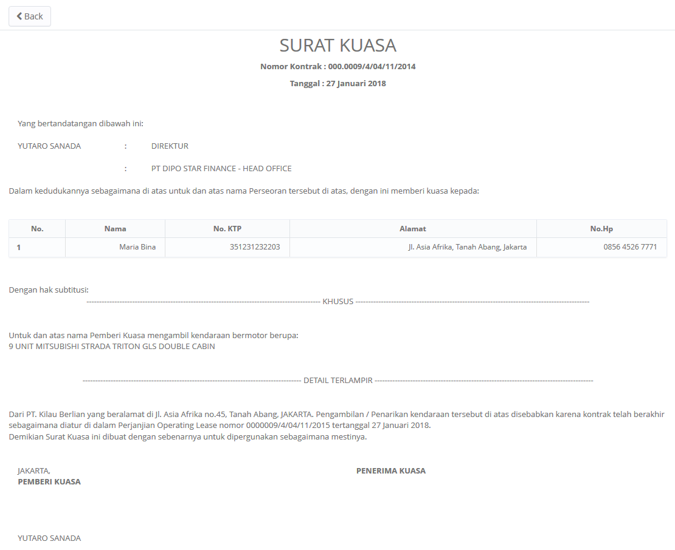

1

2

3

4

5

6

7

8

9

10

11

12

13

14

15

16

17

18

19

20

22

23

21

24

26

25

28

27

29

**RPT.AE.1.4 Return of Authorization Letter History**

|  |  |  |  |  |
| --- | --- | --- | --- | --- |
| *No.* | *Content* | *Description* | *Source* | *Remarks* |
| 1 | RAL Report’s file name | Purchase Order Report_MMddyyy_hhmm where MMddyyy and hhmm is the time when button Print Report is clicked | System Automatic generate |  |
| 2 | RAL Monthly Report | Title of the report |  |  |
| 3 | Period | Period monthly Report | Based on selected Start Date and End Date that already select by User when print Report | Format display Report:  MM/dd/yyyy |
| 4 | Status | Status of the report | Based on selected Search Criteria: Status |  |
| 5 | DSF Office | Branch Short Name | TB_OPL_Branch.BranchShortName |  |
| 6 | Agreement Number | Agreement Number | OPLAgreement.AgreementNumber |  |
| 7 | Customer Name | Customer Name | Customer.CustomerName | TB_BIL_PaySchedule.IdOPLAgreement |
| 8 | Unit Description | Unit Description | Product.BrandName + Product.ModelName | Where TB_BIL_RAL.IdTb_BIL_PaySchedule = TB_BIL_PaySchedule.IdTb_BIL_PaySchedule  AND  TB_BIL_PaySchedule.IdOPLAgreement = Tb_OPL_Unit.IdOPLAgreement  AND  Tb_OPL_Unit.ProductCode = Product.ProductCode |
| 9 | Total Unit | Total Unit | OPLAgreement.TotalUnitQuantity | Where  TB_BIL_RAL.IdTb_BIL_PaySchedule = TB_BIL_PaySchedule.IdTb_BIL_PaySchedule  AND  TB_BIL_PaySchedule.IdOPLAgreement = OPLAgreement.IdOPLAgreement |
| 10 | Last Modified By | User Name who last modify data | TB_BIL_RAL.LastModifiedBy |  |
| 11 | Last Modified Date | The date when data modified | TB_BIL_RAL.LastModifiedDate | Format display Report:  MM/dd/yyyy |
| 12 | Status | Status of RAL | Tb_OPL_Status.StatusCode |  |
| 13 | Page | Number of Report Page | Automatically count by number of page |  |
| 14 | Printed By | Printed By | Sys.CurrentUser |  |
| 15 | Printed Date | Printed Date | Use date at server when button Print Report is clicked | Format display Report:  MM/dd/yyyy |

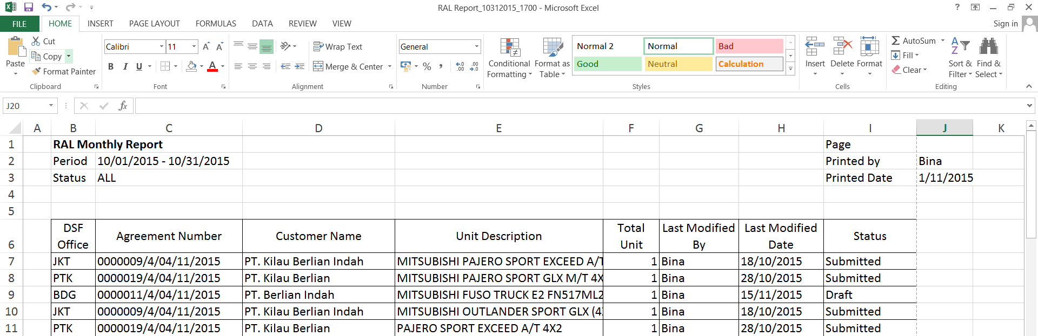

1

2

3

4

5

6

7

8

13

14

15

9

10

11

12

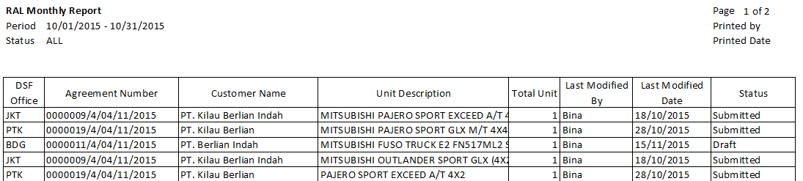

**Note:**

Content number 2, 3, 4, 5 and 6 will be page header format and will be printed in every page.

* 1. Entity Relationship Diagram

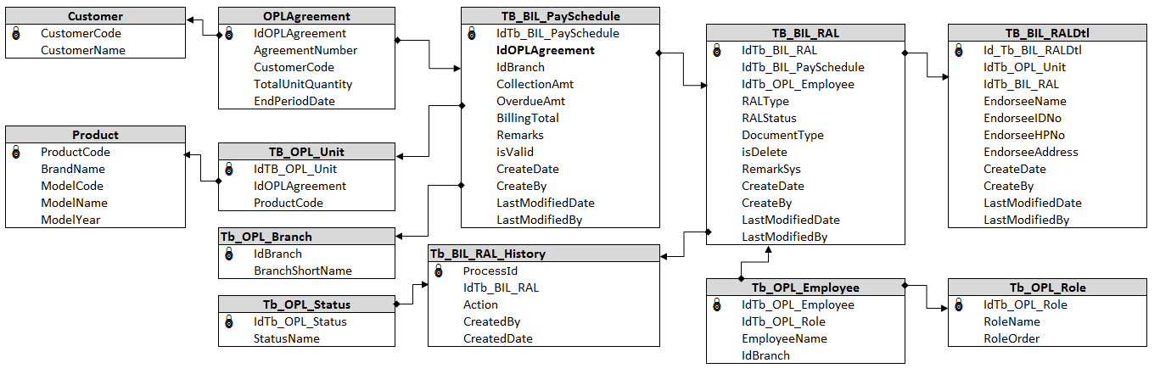

**APPENDIX**

Configuration Access for Manage Return of Authorization Letter:

|  |  |  |  |  |  |  |  |
| --- | --- | --- | --- | --- | --- | --- | --- |
| **User** | **Branch** | **Functions** | | | | | |
| **Display List** | **Create** | **Edit** | **View** | **Print Form** | **Print Report** |
| PIC Collection | One | V | V | V | V | V | V |
| Area |  |  |  |  |  |  |
| All |  |  |  |  |  |  |
| Head of Branch | One | V |  |  | V | V | V |
| Area |  |  |  |  |  |  |
| All |  |  |  |  |  |  |
| Head of Department | One |  |  |  |  |  |  |
| Area |  |  |  |  |  |  |
| All | V |  |  | V | V | V |
| Regional Manager | One |  |  |  |  |  |  |
| Area | V |  |  | V | V | V |
| All |  |  |  |  |  |  |
| Advisor | One |  |  |  |  |  |  |
| Area |  |  |  |  |  |  |
| All | V |  |  | V | V | V |
| Director | One |  |  |  |  |  |  |
| Area |  |  |  |  |  |  |
| All | V |  |  | V | V | V |
| President Director | One |  |  |  |  |  |  |
| Area |  |  |  |  |  |  |
| All | V |  |  | V | V | V |
| Shareholder's Meeting | One |  |  |  |  |  |  |
| Area |  |  |  |  |  |  |
| All | V |  |  | V | V | V |
|  |  |  |  |  |  |  |  |
| **Legend:** |  |  |  |  |  |  |  |
| V = Have the access |  |  |  |  |  |  |  |